QUALIFICATION ROUND PREP TUTORIAL
PROBLEM C
Text encoding refers to how texts (like the message we type during whatsapp chats) are transmitted from the sender to the receiver’s phone or laptop.
Computers process and transmit information, example texts, in bits.
A bit is either 0 and 1, hence they are also called binaries. A binary is a method of representing any number in 0s and 1s. For example, 5 in binary is 101.
For standard text encodings, the same number of bits is used for each character.
Assuming in this instance, 4 bits (thus any four combinations of 0 and 1, like 1001, 0101 etc) are used to encode each character.

Note, the number of bits determines how much data bundle is used.
8bits = 1 byte
1024 bytes = 1 Kilobyte (KB)
1000 Kilobytes (KB) = 1 Megabyte (MB)
1000 Megabytes (MB) = 1 Gigabyte (GB)

If I decide to send this message to you, CAAAAABBBDCAABBCCDDAAAB, using the standard text encoding approach, the number of bits used is calculated below.
Using 4 bits for each character

A = 1011
B = 1101
C = 1110
D = 0111

count of character A = 10
length code of A = 0111 = 4 bits
data required for the A characters = count of character A * length code of A
=> 10 * 4
= 40 bits

count of character B = 6
length code of B = 1101 = 4 bits
data required for the B characters = count of character B * length code of B
=> 6 * 4
= 24 bits

count of character C = 4
length code of C = 1110 = 4 bits
data required for the C characters = count of character C * length code of C
=> 4 * 4
= 16 bits

count of character D = 3
length code of D = 0111 = 4 bits
data required for the D characters = count of character D * length code of D
=> 3 * 4
= 12 bits

Total data required to transmit CAAAAABBBDCAABBCCDDAAAB using the same number of bits for each character is
=> 40 + 24 + 16 + 12
= 64 + 28
= 92 bits

In using different length codes (length codes means the length of the bits differ, thus some characters may have 101, others 1001, or 111111 etc) for characters with different probabilities,
the characters with the highest probabilities would have the shortest length codes.
For example, if
probability(A) = 0.50,
probability(B) = 0.30,
probability(C) = 0.20,
probability(D) = 0.10

then using different length codes imply:
So each character is encoded with the digit 1 and 0 only...Let’s assume the maximum number of bits is 4
D with the lowest probability would be fully encoded in the maximum number of bits, 4 bits;

length code of D = 1101

C with the second lowest probability would be encoded with 1 bit less than the maximum, thus 4 -1 = 3 bits;

length code of C = 101

B with the second highest probability would be encoded with 2 bits less than the maximum, thus 4 - 2 = 2 bits;

length code of B = 10

A with the highest probability would be encoded with 3 bits less than the maximum, thus 4 - 3 = 1 bit;

length code of A = 1

So if the message contains this statement:

CAAAAABBBDCAABBCCDDAAAB

the data required would be:

count of character D = 3
length code of D = 1101 = 4 bits
data required for the D characters = count of character D * length code of D
=> 3 * 4
= 12 bits

count of character C = 4
length code of C = 101 = 3 bits
data required for the C characters = count of character C * length code of C
=> 4 * 3
= 12 bits

count of character B = 6
length code of B = 10 = 2 bits
data required for the B characters = count of character B * length code of B
=> 6 * 2
= 12 bits

count of character A = 10
length code of A = 1 = 1 bit
data required for the A characters = count of character A * length code of A
=> 10 * 1
= 10 bits

total data required would then be = 12 + 12 + 12 + 10

=> 36 + 10
= 46 bits

Transmitting CAAAAABBBDCAABBCCDDAAAB would require 46 bits of data when different length codes for characters with different probabilities is applied.

Using different length codes for characters with different probabilities would save 46 (92 - 46 = 46) bits of extra data which could be used to add more characters to the message, hence allowing for more messages to be transmitted than when using the same number of bits for each character.

Use this same reasoning to answer Problem D, questions 1, 2 and 3
# QUESTION 1 and 2
Note: In Optimal encoding (optimal encoding refers to ensure the right message is transmitted from one person to the other. For eg, if I send “Come here”, we expect “Come here” to appear on the receiver’s device. If the message is not optimally encoded, some of the characters may get missing like and this might appear on the receiver’s device “me re”).

In optimal encoding, an entropy value of 3.0191 bits implies you need an average of 3.0191 bits of data bundle to send a message. For instance, if you want to send an image to a friend on whatsapp and the theoretical entropy limit for sending the image is 24 MB. Optimal encoding would then mean you need at least 24 MB to send the image. If your data bundle is less than 24 MB, the image cannot be fully sent.
# QUESTION 3
Formula for calculating the average code length of fano code
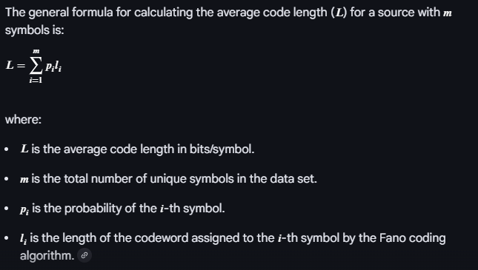

An efficient Fano code has an average code length very close to the theoretical
entropy limit (thus, the Shannon entropy).
So compare the result of the Fano code to the theoretical entropy limit you calculated above. If they are close, then the Fano code is efficient.
If they are not close then the Fano code is not efficient.

